
Name = Muhammad Daniyal
Registration no = 24371
Date = 04/05/2026
Submitted to : Mam Faryal

Software Construction and Development CA

Lab 08

Task 1
  - Create a structure Student with members:

    - name
    - roll
    - gpa
  - Input values for the student.
  - Display the stored information.
Input/output:
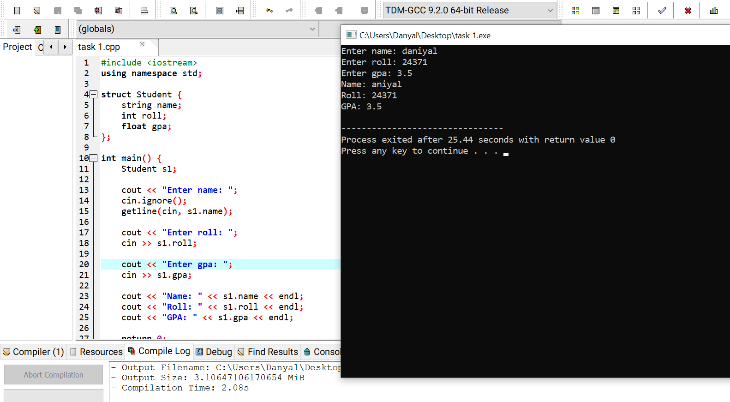
Task 2

- Create a structure Laptop with members:

  - brand
  - ram (in GB)
  - price

- Input laptop data.
- Display laptop specifications.
Input/output:
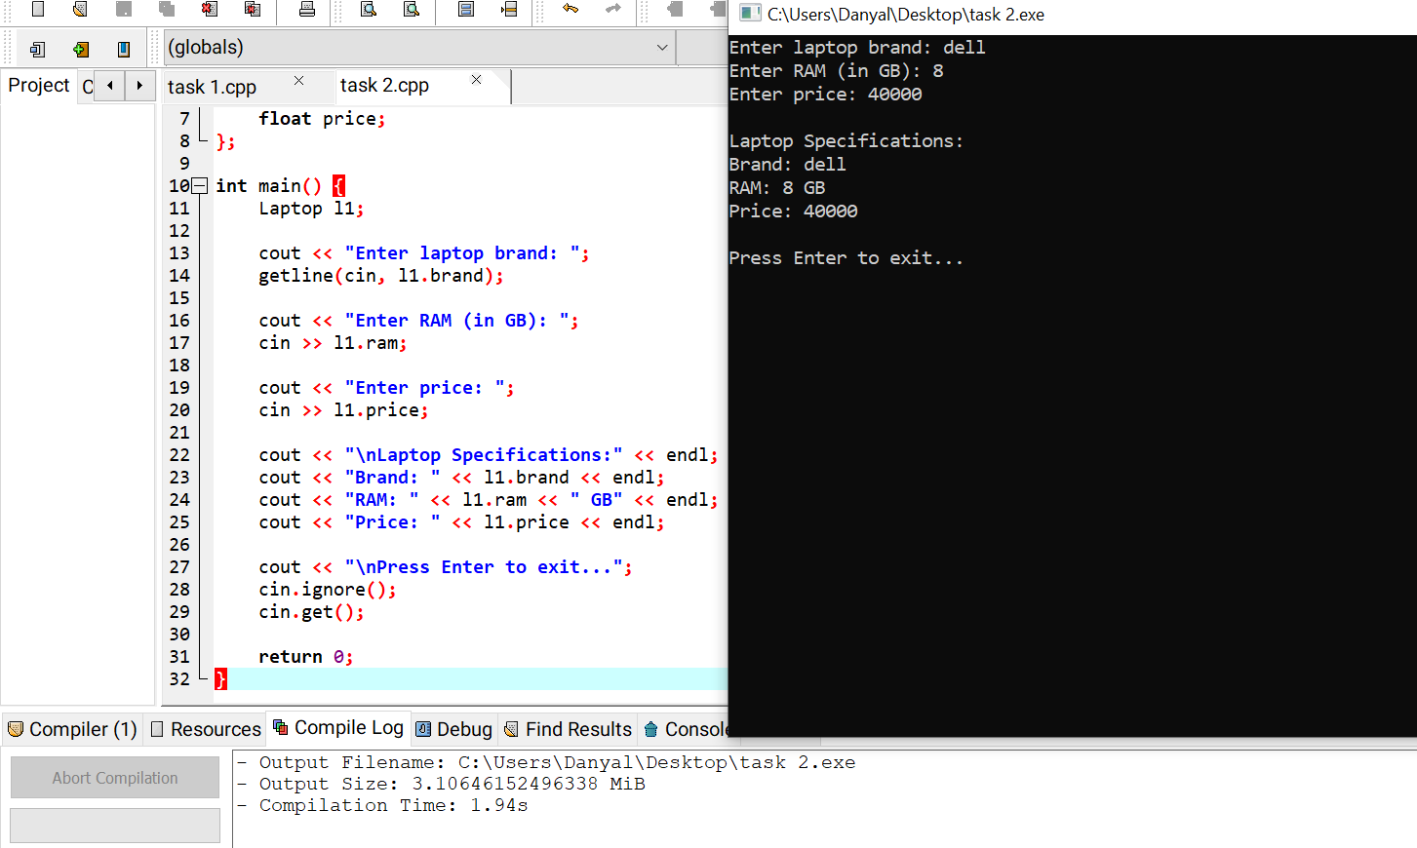

Task 3

- Create a structure Rectangle with members:

  - length
  - width

- Input values from the user.
- Calculate and display the area and perimeter.
Input/output:
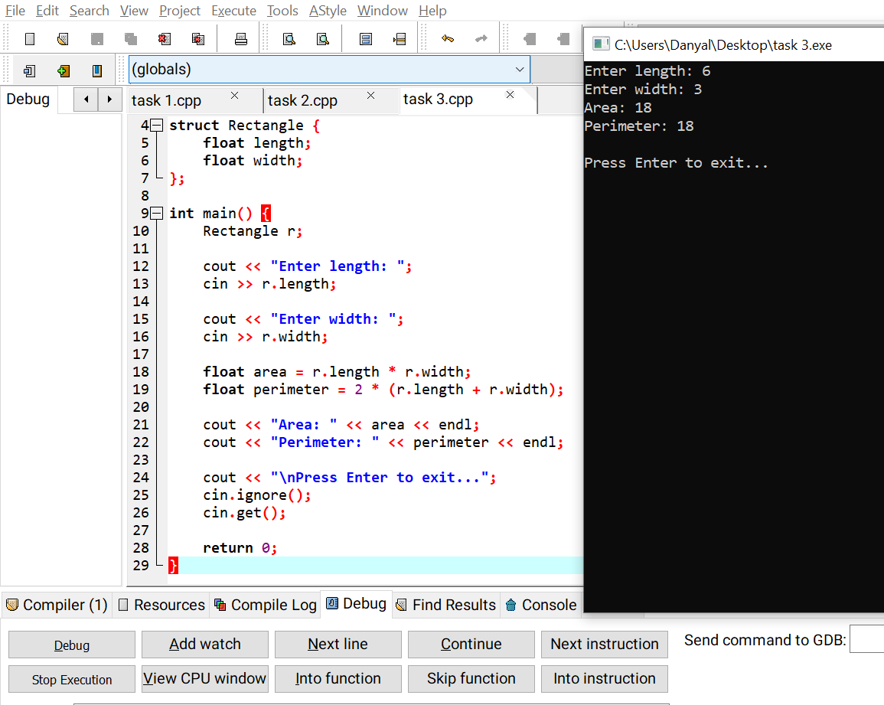

Task 4

Create a structure Student with the following members:

  - name
  - roll
  - gpa
Input/output:
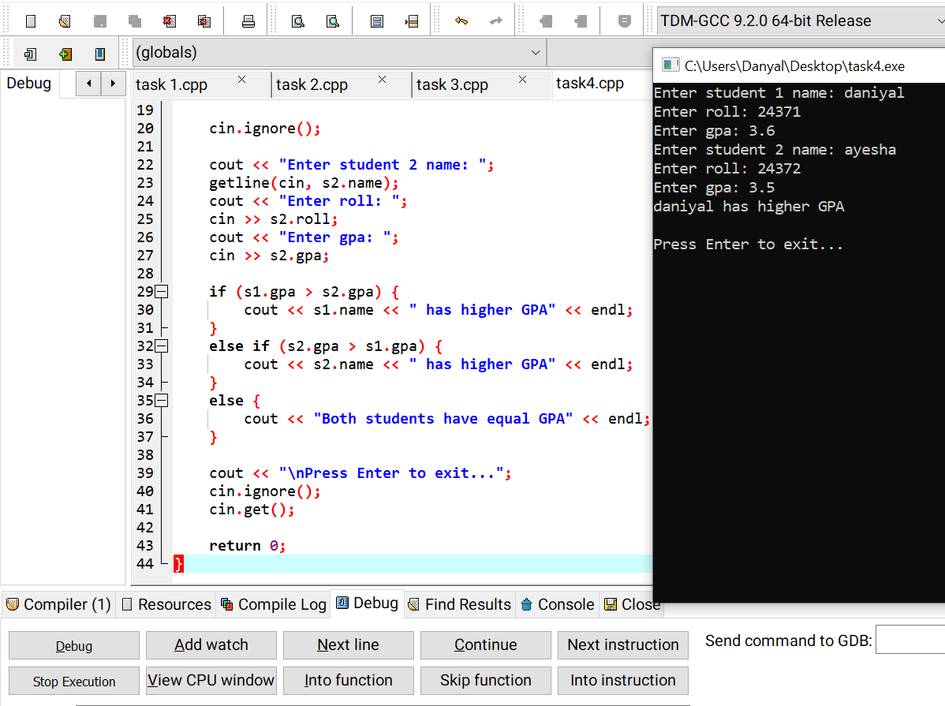

The End

